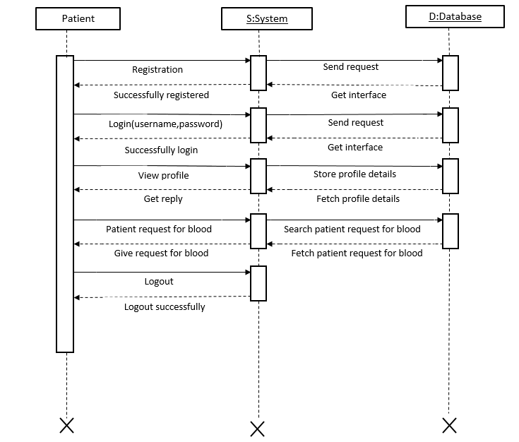

Patient

Fetch patient request for blood

Search patient request for blood

Fetch profile details

Store profile details

Get interface

Send request

Get interface

Send request

Logout successfully

Logout

Give request for blood

Patient request for blood

Get reply

View profile

Successfully login

Login(username,password)

Successfully registered

Registration

S:System

D:Database